You Are Pretty Funny: Humor is Not Necessarily Attractive
Tommy Ager, Clemence Mendoza, Lisa Ngo, Melissa Wong
March 17, 2015
Honors 221
Section 10:30

Abstract
Does humor influence attractiveness? To answer this question we designed an anonymous online survey through Google Forms containing pictures of 12 male and 12 female models with speech bubbles of funny or neutral statements. We then asked participants to look at each model and read the statement in the speech bubble before rating the models based on attraction. We hypothesized that humor increases attractiveness. However, our results show that humor is not always an indicator of attractiveness. On average, participants rated male and female models as less attractive when paired with funny statements. Thus, despite some methodological issues, we conclude that humor is not necessarily an indicator of attractiveness.

Introduction
Does humor influence attractiveness? Humor is often seen as an attractive trait in a partner. Sexual selection for humor could result from the perception that humor is an indicator of how well an individual navigates social situations, a trait valued by modern societies. We based our independent research project aimed to answer this question on a study by Bressler and Balshine (2006) titled The Influence of Humor on Desirability. Our hypothesis was that humor would increase attractiveness.
Methods
We created a survey through Google Forms containing pictures of male and female models with speech bubbles of funny or neutral statements. After collecting information about the participants’ age, sex and gender of preference, the participants would proceed to one of two forms of the survey for the gender they designated. One form had photos of 12 models paired with a mixture of funny and neutral statements; the other form contained the same photos of the 12 models, but with a different statement, opposite to what their photo was paired with in the first form (Supp. 1-3). Participants were presented with photographs of each model and then asked to rate the model’s attractiveness on a scale of 1-7 (1= not attractive, 7= highly attractive). After rating all 12 photos, participants reported how much the statements, physical attractiveness and ethnicity affected their ratings (scale from 1-4, 1= not at all, 4=a lot). We analyzed the data by calculating the average ratings of each model when paired with funny vs. neutral statements and compared the difference in those values to observe whether humor increased or decreased attractiveness. If the hypothesis that humor increases attractiveness is correct, then there would be an increase in attractiveness for humorous individuals for both female and males. (Fig. 1A). If hypothesis was incorrect, then there would be no increase in attractiveness for humorous individuals for either gender (Fig. 1B).

Results and Analysis
From the data, it seems that humor is not always a strictly attractive trait. This is the opposite of what we hypothesized, since the original study found that people tended to choose humorous mates. On average, our respondents ranked “humorous” models about 0.5 points less attractive than “non-humorous” models (Fig. 2). However, participants are not universally ranking funny people as unattractive when looking at average attractiveness of each individual model (Fig. 3A-B). In this case, it’s important to make sure that the statements are in fact altering peoples’ judgements of attractiveness. In the post-survey, people reported on average that while physical attractiveness was the more important factor, the statements were also making a difference (Fig. 4). In which case, there are other potential factors that cause these responses to be different.
At first it seems that our study has results that are the opposite of what Bressler and Balshine found, since they discovered that people generally select humorous people as good potential mates. However, upon closer inspection our results were not that dissimilar. Bressler and Balshine measured for individual perceived personality traits, whereas we only measured for general attractiveness. The original study found that while humorous people were evaluated as more confident and individualistic, they were also seen as less intelligent and less trustworthy. It is possible that the negative perceptions of the models were greater than their more positive interpretations and that influenced the participants’ rating of each model’s attractiveness.
We identified a number of potential issues with our study, as well as with the original study. For our study, we didn’t have access to totally neutral photos of models. We were hoping that since the results would be measured only from the differences between identical photos with different statements, the absolute values of the attractiveness of the models would be relatively unaffected by other factors. However, it is entirely possible that the appearances of our models were interacting with the perceived humor of the statements, particularly in terms of facial affect and general physical attractiveness. In both studies, there were also problems with the statements. The original researchers noted that the “juvenile nature” of the statements could have affected how the producers of the statements. Perhaps the most prevalent issue with the statements is our method of delivery. Many of the statements, which may have been funny in certain contexts, have very different connotations when delivered with no conversational context. They also exist only in written form, meaning the reader can apply any kind of tone of voice to the statements. That tone may have been excessively affected by cues given on the photo of the model. Finally, the last potential problem we identified is that of cultural differences. The original study was distributed in Ontario, Canada, whereas ours was given largely to participants here in America. Cultural differences may have attributed to different interpretations of the statements.

Conclusions and Further Questions
Overall, both the original study and ours concludes that humour is not necessarily associated with positive traits. In addition, our study suggests that humour is also not always associated with attractiveness. Due to problems in methodology, further research is necessary to ascertain the role of humor in evaluating attractiveness. An improved survey would be to find more neutrally humorous statements, and then have an audio clip of the statement play while a participant looks at a photo of a neutral expression model. In this way, the chance of participants mentally reading statements in a negative tone of voice is reduced. Furthermore, it would be interesting to cross-analyze how much each measured personality trait (such as intelligence, confidence, etc) affects perceptions of attractiveness. By doing this one could simultaneously see what personality traits are being altered by humor and how important those traits are to general attractiveness, and then be able to understand better the overall effect of humor on attractiveness.

Appendix
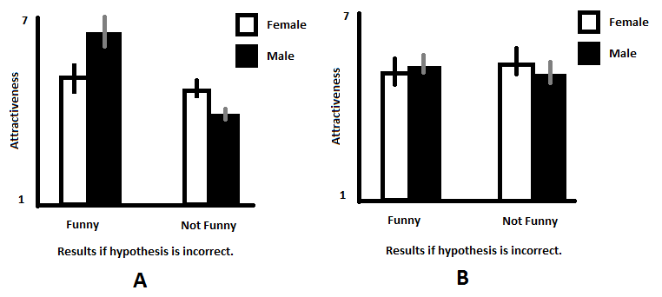
Figure 1: Graph of average ratings of attractiveness on models associated with funny quote or neutral quote.
Figure 1A: Graph that shows if hypothesis was correct. If the hypothesis is correct, then there would be an increase in attractiveness for humorous individuals for both female and males.
Figure 1B: Graph that shows if hypothesis was incorrect. If hypothesis was incorrect, then there would be no increase in attractiveness for humorous individuals for either gender.

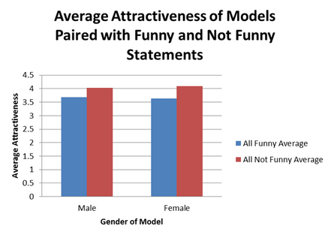
Figure 2: Graph of actual results on average attractiveness by gender. The average attractiveness was higher for both female and male models when paired with a neutral, non-funny quote.
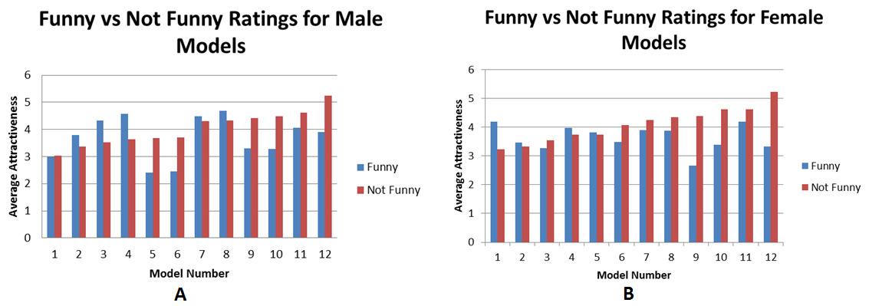
Figure 3: Graph of the actual results on average attractiveness within each individual male (3A) and female (3B) models when paired with funny or neutral, non-funny quote.

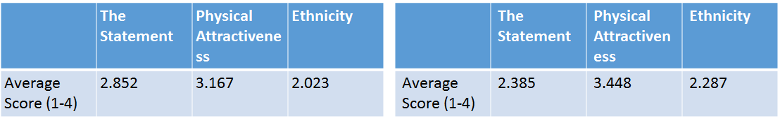
Figure 4: Table of factors influencing participants’ decisions on rating models’ attractiveness.

Work Cited
Bressler, Eric R., and Sigal Balshine. “The Influence of Humor on Desirability.” Evolution and Human Behavior 27, no. 1 (January 2006): 29–39. doi:10.1016/j.evolhumbehav.2005.06.002.

Supplemental Figures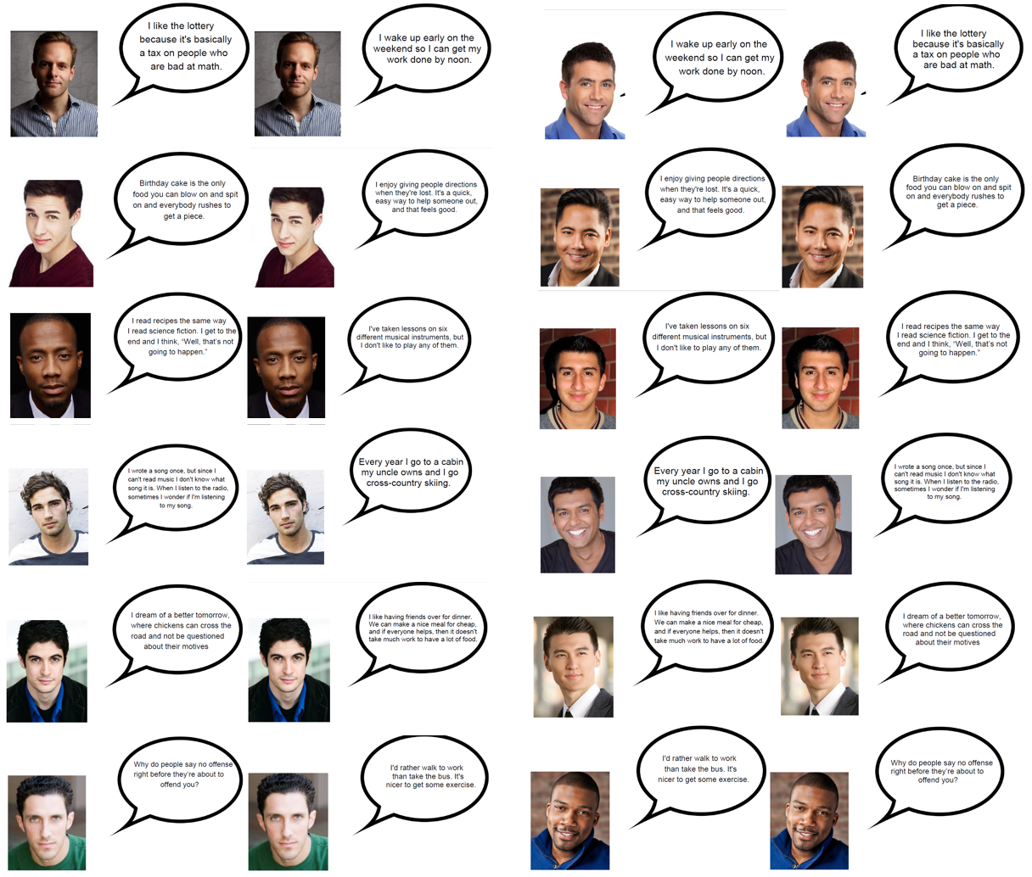
Supplemental Figure 1: Images of male models 1-12 associated with a neutral quote (left) and a funny quote (right).
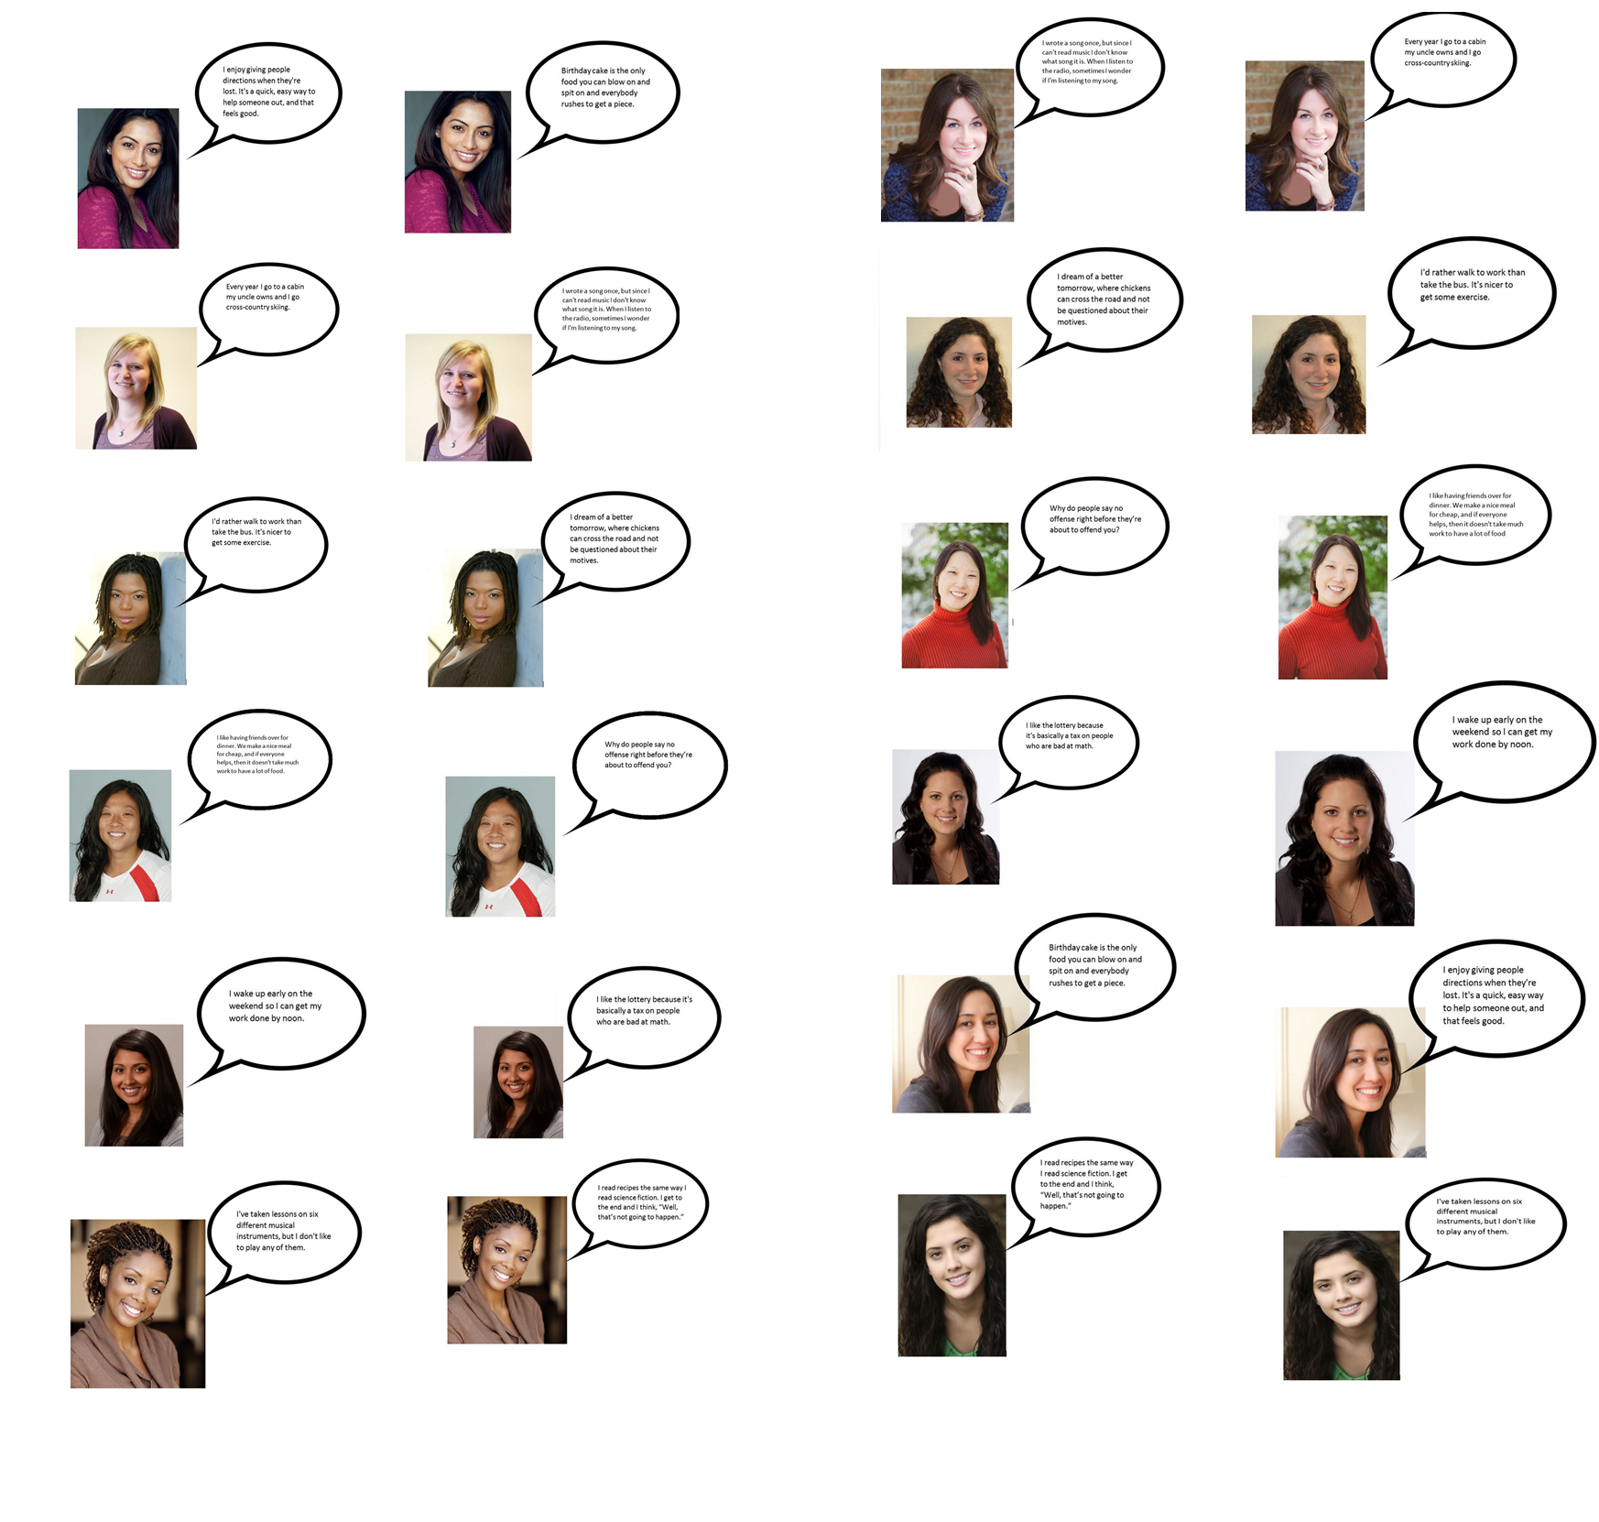
Supplemental Figure 2: Images of female models 1-12 associated with a neutral quote (left) and a funny quote (right).

Funny Quotes:
- I like the lottery because it's basically a tax on people who are bad at math.
- Birthday cake is the only food you can blow on and spit on and everybody rushes to get a piece.
- I read recipes the same way I read science fiction. I get to the end and I think, “Well, that’s not going to happen.”
- I wrote a song once, but since I can't read music I don't know what song it is. When I listen to the radio, sometimes I wonder if I'm listening to my song.
- I dream of a better tomorrow, where chickens can cross the road and not be questioned about their motives.
- Why do people say no offense right before they’re about to offend you?

Neutral Quotes:
- I wake up early on the weekend so I can get my work done by noon.
- I enjoy giving people directions when they're lost. It's a quick, easy way to help someone out, and that feels good.
- I've taken lessons on six different musical instruments, but I don't like to play any of them.
- Every year I go to a cabin my uncle owns and I go cross-country skiing.
- I'd rather walk to work than take the bus. It's nicer to get some exercise.
- I like having friends over for dinner. we make a nice meal for cheap, and if everyone helps, then it doesn't take much work to have a lot of food.

Supplemental Figure 3: One funny quote and one neutral quotes were assigned to each model.

